**A DATA DRIVAN EXPLORATION OF APPLE’S IPHONE IMPACT IN INDIA**

1.INDRODUCTION:

**1.1 Overview**

The world has changed as a consequence of the increasing use of smartphones, which have improved communication, connected people, and revolutionized many different businesses. With its main product, the iPhone, capturing markets around the world, Apple Inc. has emerged as a prominent player among the top smartphone makers. India, one of the economies with the greatest economic growth, has seen a tremendous increase in smartphone usage, making it an interesting market to study the effects of Apple's iPhone.

**1.2 Purpose**

Problem Understanding, also known as Problem Definition or Problem Identification, is the initial and critical phase of any data analysis or problem-solving process. It involves gaining a clear and comprehensive understanding of the problem at hand, its context, scope, and objectives

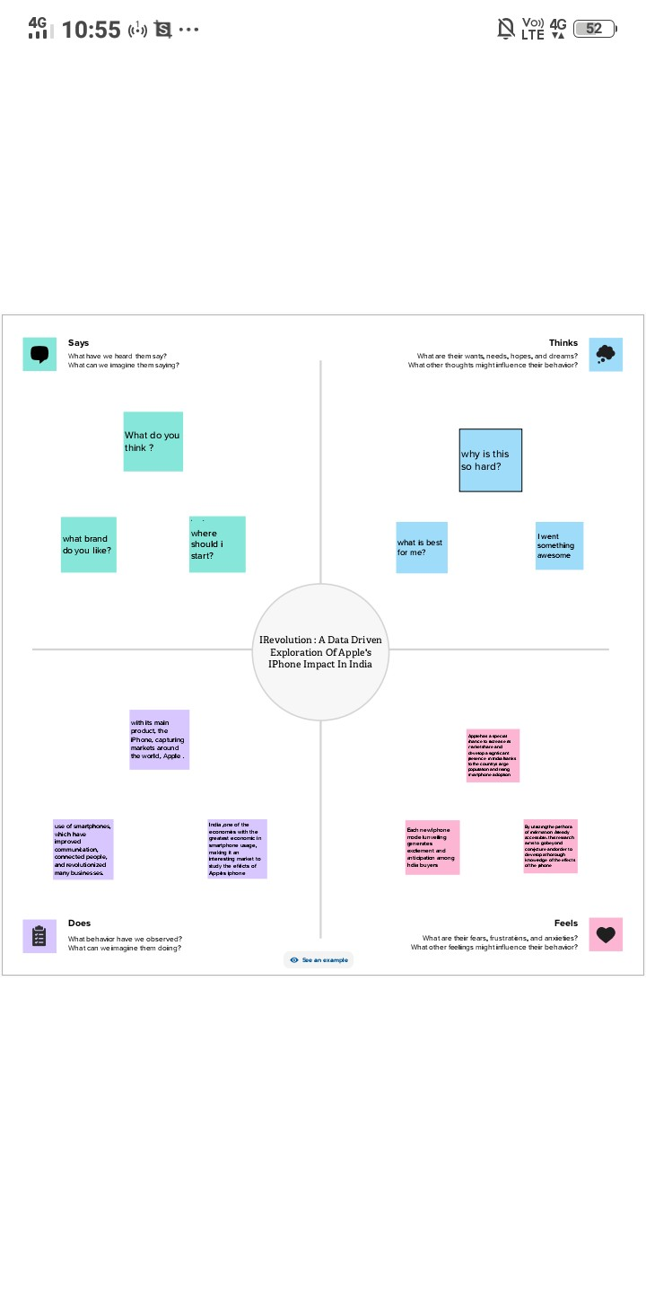

**EMPATHY MAP**

2.2 IDEATION & BRAINSTORMING MAP

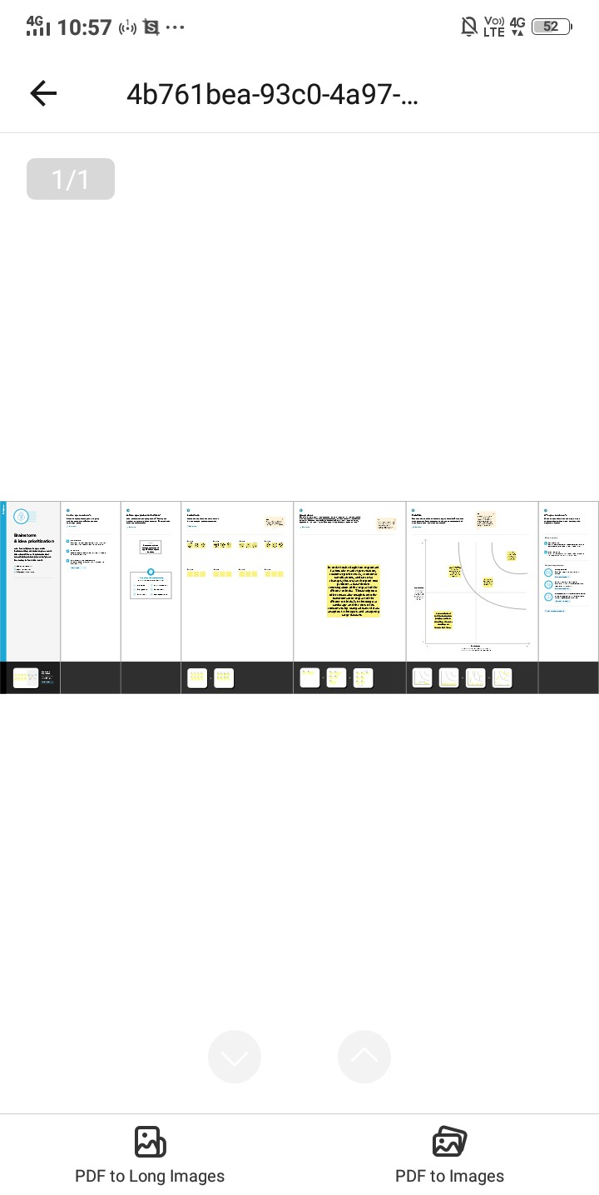

DASHBOARD

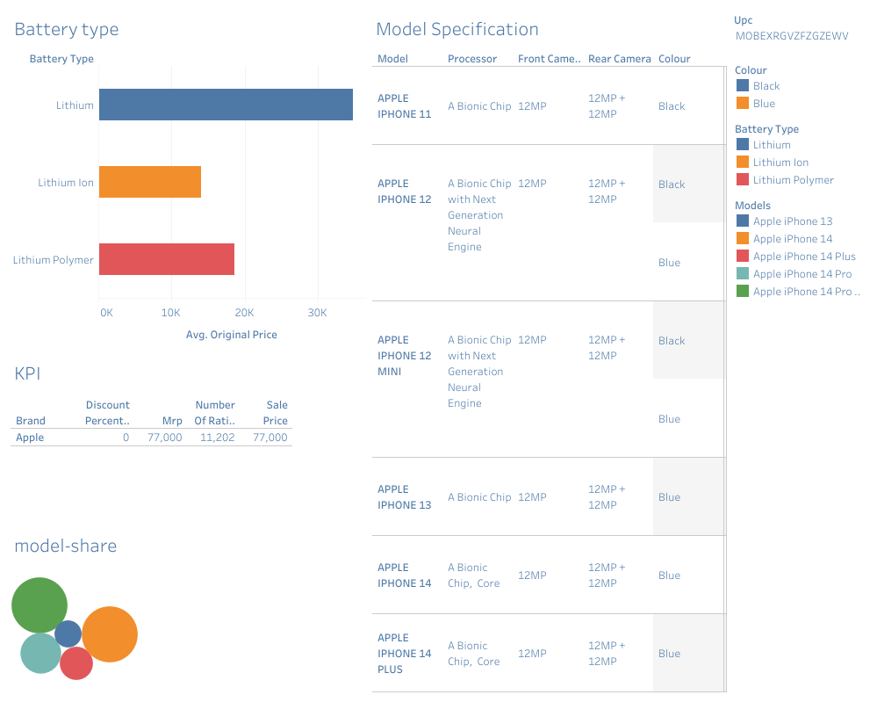

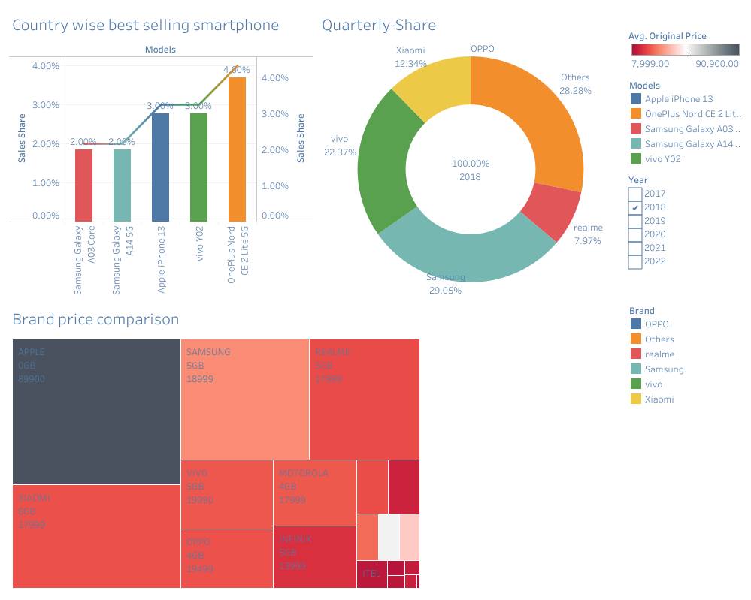

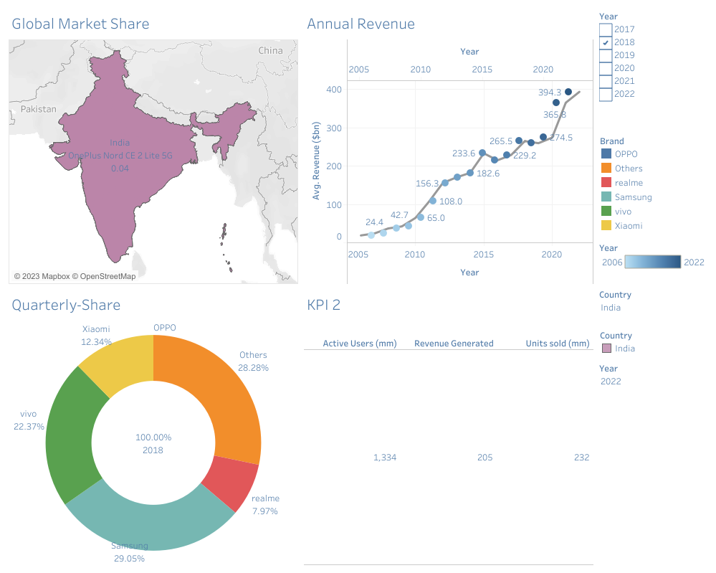

**STORY**

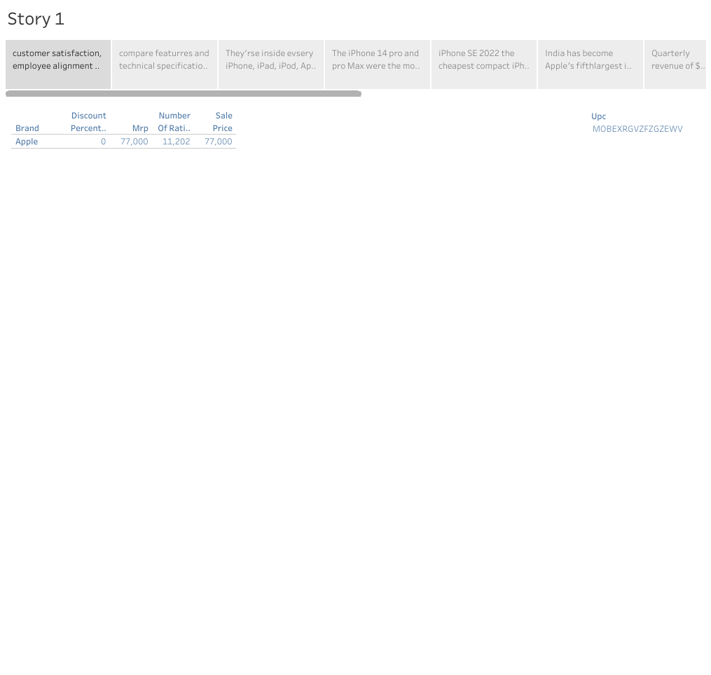

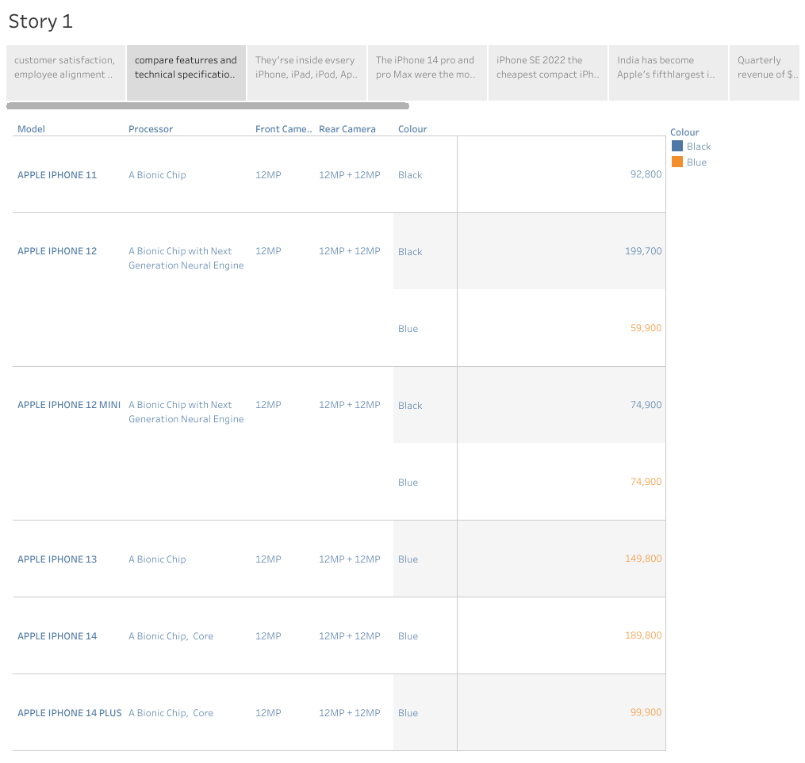

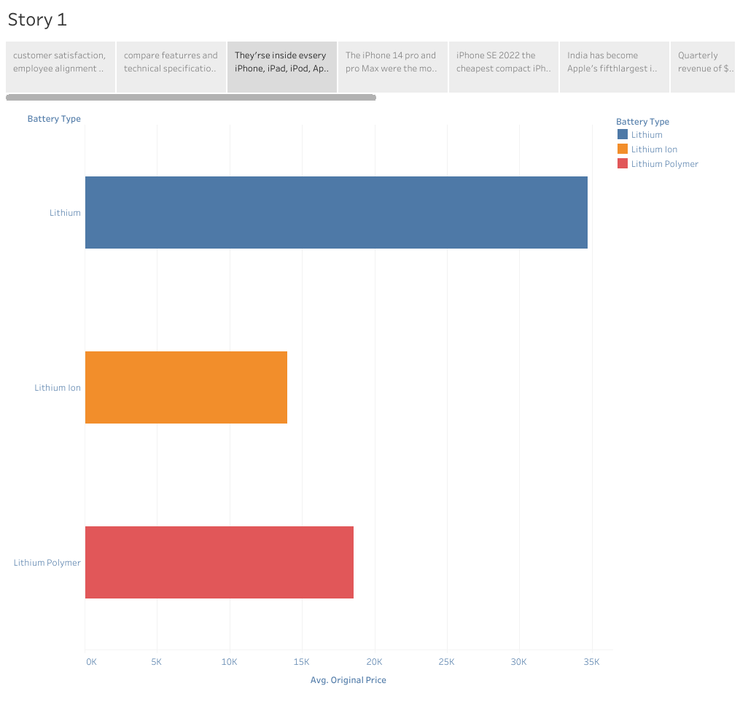

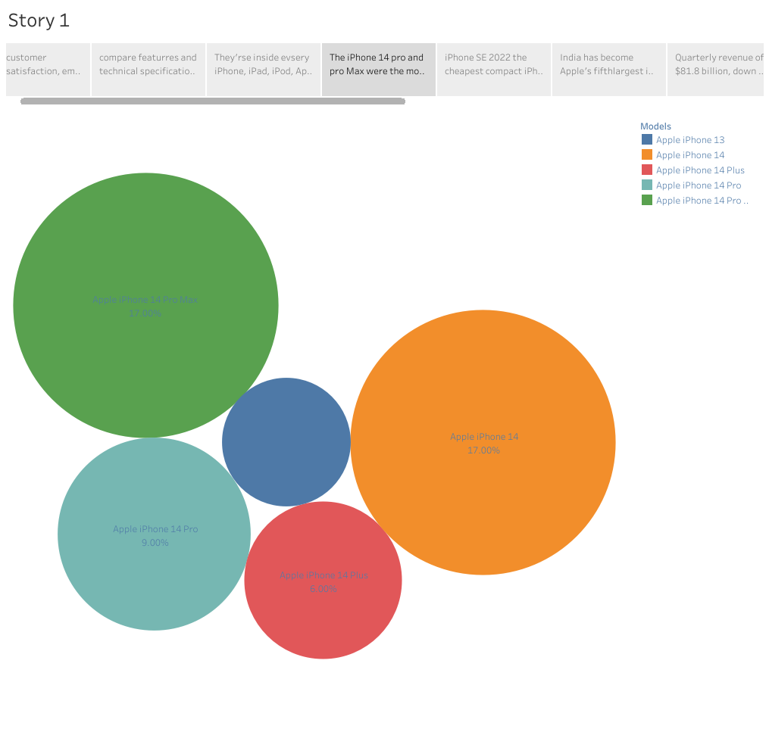

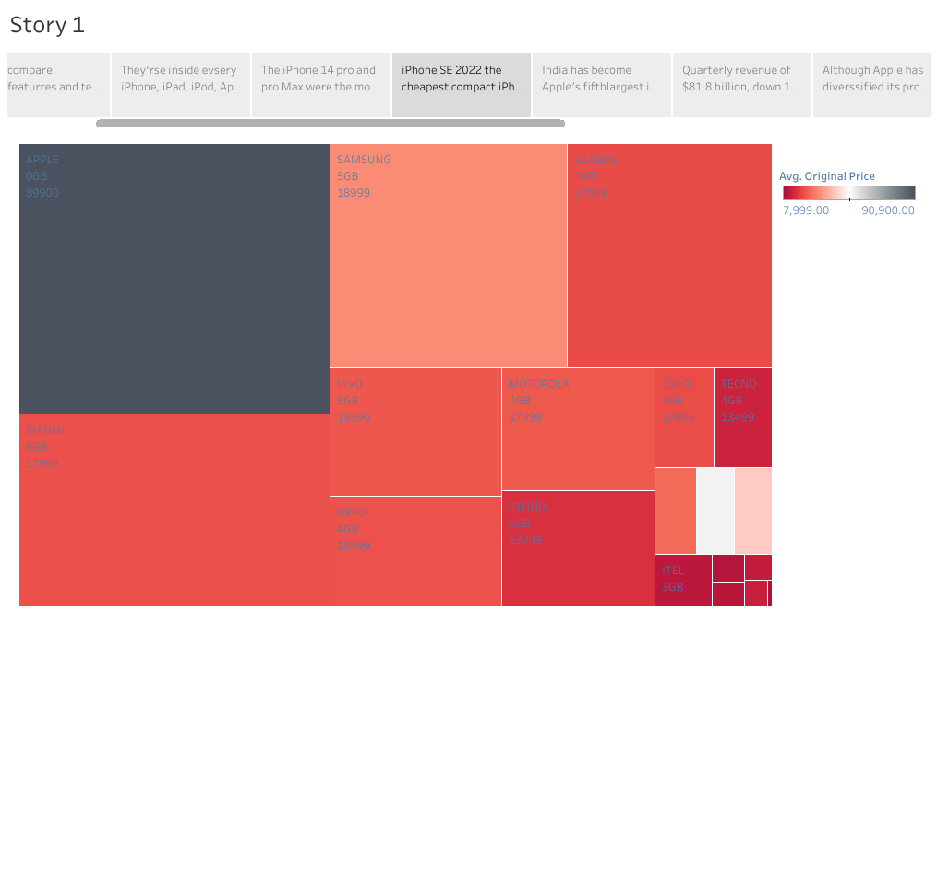

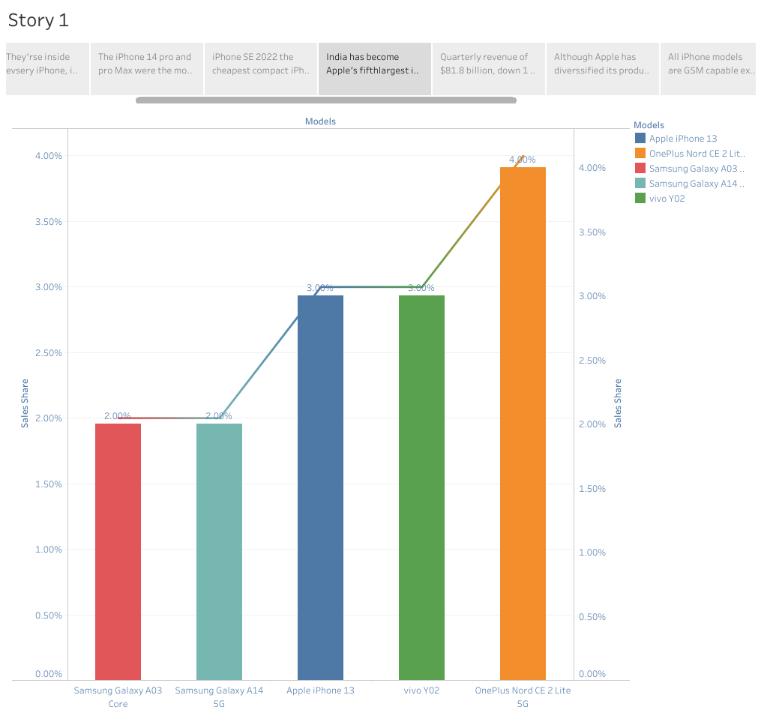

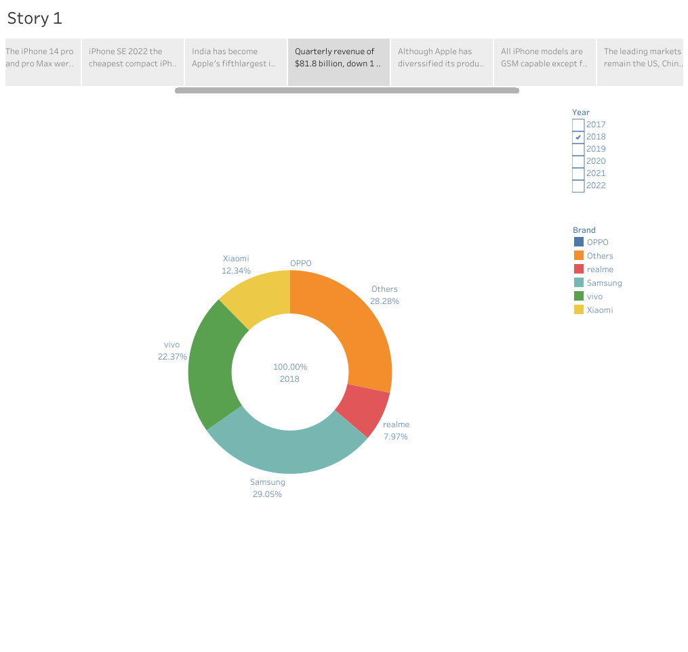

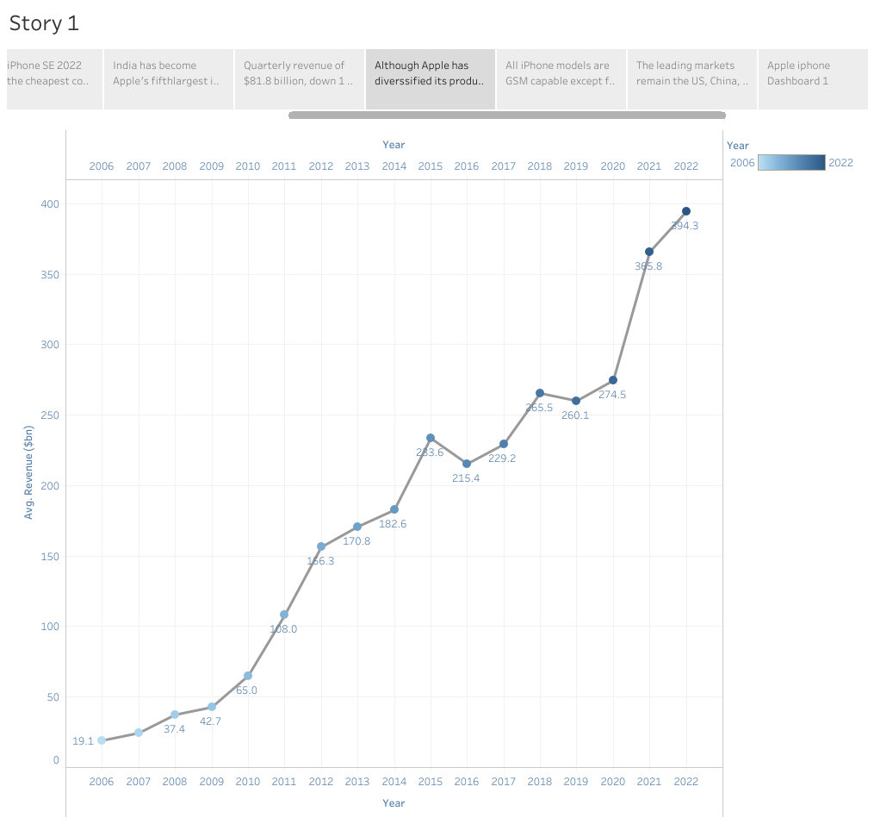

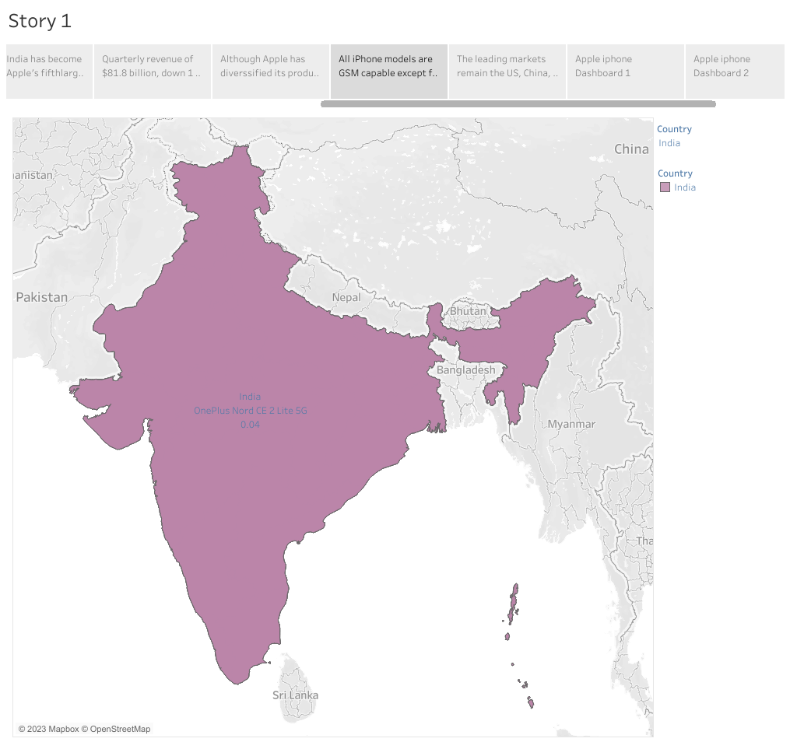

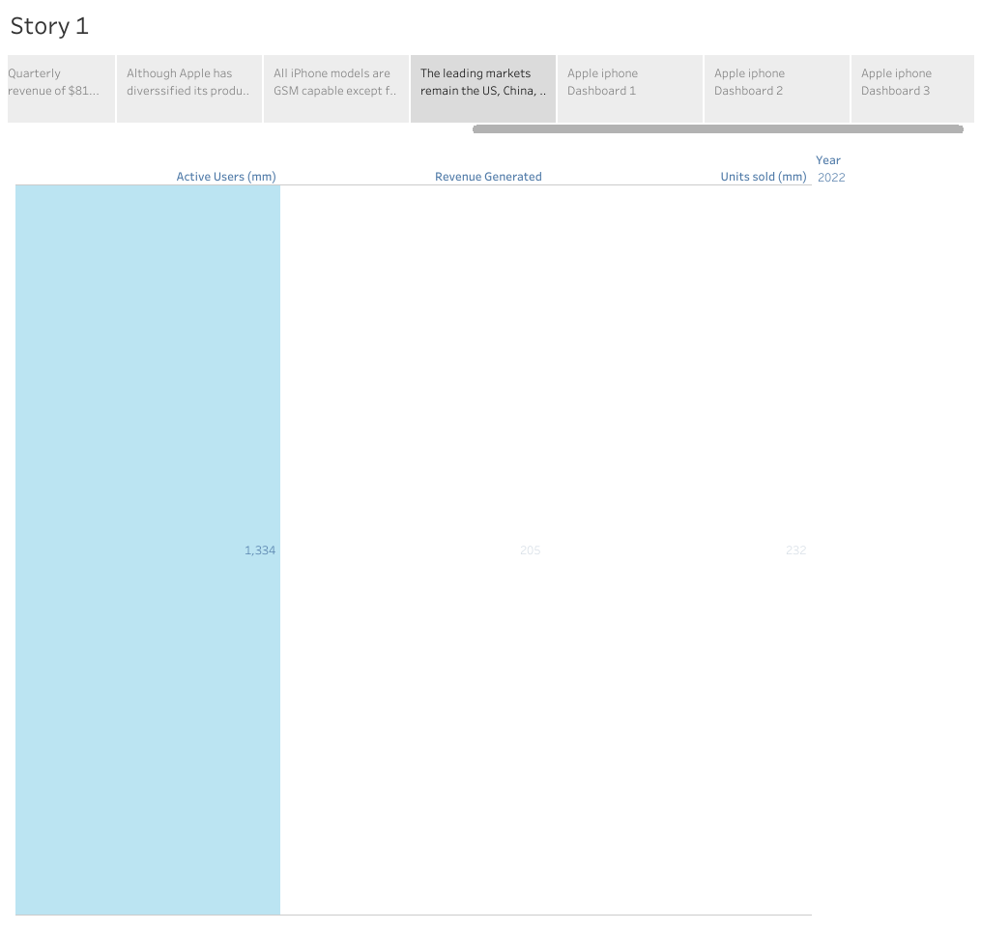

4. ADVANTAGE & DISADVANTAGE

ADVANTAGE:

* User-Friendly Interface the iPhone has an intuitive user interface that makes it easy to navigate.
* High Quality Display the Retina display is one of the best in the market.
* Advanced Camera iPhone devices have some of the best known to produce stunning images and videos of the highest quality.
* Apps Ecosystem the App Store is unparalleled in terms of access and ease of use.

**DISADVANTAGE**

* Cost the iPhone is one of the most expensive smartphones on the market. But makes it a luxury item for many people.
* Non-Removable Battery the iPhone’s batteries are non-removable, which means that users cannot replace them.
* Limited Customization one of the disadvantages of the iPhone is that it has limited customization options.
* No Expandable Storages another disadvantage of the iPhone is that it has no expandable storage options.

**5. APPLICATIONS:**

The project's business needs call for data analysis and visualization in order to understand how Apple's iPhone has affected India. This entails looking at customer choices, market penetration, sociological developments, and economic effects. Tableau visualizations should be interactive, understandable, and educational so that stakeholders can make data-driven decisions and comprehend the impact of the iPhone on the Indian market.

**6. CONCLUSION:**

An important component of this study is the societal impact of Apple's iPhone in India. We intend to investigate how the iPhone has altered communication, information access, and social relationships in Indian society through data analytics and Tableau visualizations. Studying the impact of iPhones on social media use, online content consumption, and the broader digital divide are all included in this. Policymakers and organizations can better manage the benefits and difficulties brought on by the expanding smartphone adoption by understanding the social impact.

**7. FUTURE SCOPE:**

Research must focus on how Apple's iPhone has affected business in India. We seek to examine the

economic effects of iPhone uptake in the Indian market using data analytics and Tableau visualizations.

Examining iPhone sales data, market share, revenue creation, and its effects on different industries like

e-commerce, app development, and digital payments are all part of this. Organizations can find possibilities for growth and innovation by understanding the business impact and using it to help them position themselves in their markets and make strategic decision.